English I
Weekly Letter
January 9-13
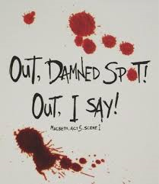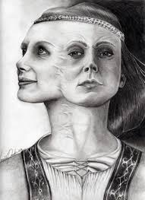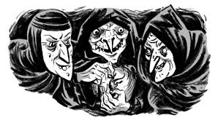

 | Expository | Compare contrast | Argument
Purpose:
Format of introduction:
Format of body:
Format of conclusion:
What are differences in format?

M Weekly Letter (complete writing section)
(Macbeth book check)
William Shakespeare A&E Biography: Take Notes---A Life of Drama
Write 10 interesting facts about the video during class
T: Continue A&E Video:
Write 10 interesting facts about the video during class

W: PowerPoint Macbeth Introduction & Macbeth's Scotland (Important Geographical Locations)
TH: The Geography of Macbeth/Macbeth's Family Tree, Tips for Reading Shakespeare, Macbeth Anticipation Guide, Reading Shakespeare's Language/what is parallel structure?

F: Begin Reading Act 1/Scene 1, Character List/Vocabulary/Packet
Macbeth PowerPoint (background information for Act I
Distribute Critical reading handout/Poetry and study guide questions for Act I
Read Act I (Scenes i-vii)
Homework: finish reading Act I and completing SG questions. With the information you learned about writing a claim: (acknowledging opposition, taking a position, stating 3 reasons in parallel structure------EDIT THIS CLAIM FROM ACT I:
Macbeth takes a dark turn mainly because of his (1) wife’s ambition ,(3)the prophecy , and (2) his own ambition for the throne.

